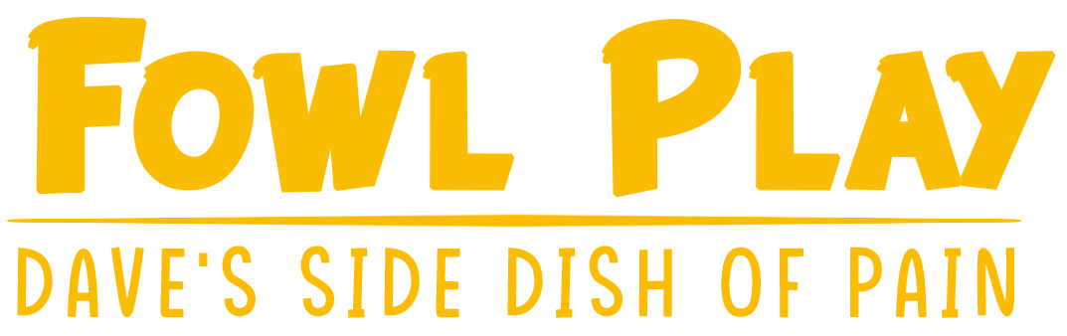

|  |  |  |  |
| --- | --- | --- | --- |
| The Sitting Ducks | | | |
| Cameron Deering | Anthony Frock | Marco Busselli | Vanessa Dimitrov |
| Producer | Designer | Programmer | Artist |

**Fowl Play: Dave’s Side Dish of Pain**

|  |  |  |
| --- | --- | --- |
| Genre | Platform | Team Size |
| Adventure | PC | 4 |

Key Points

* A silly looking game with dark roots
* The player is the main protagonist running around fighting enemies, leveling up, and gathering items / gear.
* The player fights predominantly with melee attacks while having the ability to find a blob companion that will use ranged attacks to assist fights.
* You will have health and a lives counter both of which can be replenished from items or actions throughout gameplay
* Beat each level to make it to the final room to face off against the final boss.

**The Sitting Ducks**

**Cameron Deering** - Producer

I have been playing video games for almost my whole life. So, I have a good idea on what makes a game

enjoyable and what does not. I have played many games like the one we are working on and I plan to

make sure to only include the best from this genre of game. I will be able to design wonderful and

intricate levels for our game. I am looking forward to working on this game and creating something

amazing.

As the producer of the project I have been keeping a solid track of our current status and have many

plans in progress moving forward. I have been making sure we stick to our weekly meetings to ensure

smooth progress. My video game background is second only to my dedication to this project and making

a wonderful game.

**Anthony Frock** - Designer

I have a unique experience compared to my team members. I spent 8 years in the Air Force before

coming to college so I can offer different perspectives and ideas for the project. Before all that I’ve also

played video games as long as I was able to. I’ll never forget that my very first hand held system was the

SEGA Game Gear. I have grown up with the constantly evolving game design world from the old school

8-bit games to virtual reality today.

The design aspect of the game does fall on the shoulders of all of us in The Sitting Ducks but I have been

keen on the specifics of the design. My military experience has taught me how to be very detail oriented

so nothing seems too small when it comes to the design of our game. I want to create an experience for

others that is reminiscent of my own.

**Marco Busselli** - Programmer

I would always image up game stories and gameplay mechanics when I was a kid. Entering Highschool, I

would join a special program called the Game Art and Design Academy where I would participate in

classes that would teach the basics of game design and gave me access to programming classes that

would inspire me to program professionally.

In the Academy GameMaker was one of the programs used to teach me programing since the drag and

drop feature was intuitive. It wasn’t long before I discovered GML and begin to teach myself to create

my own simple games fully in GML. Being able to bring my past GameMaker experience into focus for us

will definitely give a solid backbone to our game.

**Vanessa Dimitrov** - Artist

I am a drop out nursing student and I decided I wanted to pursue my passion of art. My goal is to get a BFA in Digital Media and Graphic design with a minor in Arabic studies. I am always striving to find innovative ways to get to the job done well. I am good at active listening and taking all ideas from teammates and creating something that makes everyone happy. Although new in the game field, I hope to one day see my work out in the world. I’d love to work with Netflix or Hulu.

As the artist, I bring our ideas to life by giving them a corporeal form. This allows us to come together and give the best product we can coming from the best ideas we have.

**Fowl Play: Dave’s Side Dish of Pain**

You play as the main protagonist of this story, Dave the Duck. Dave’s father was taken from him at a young age and he has held resentment toward this world ever since. He has survived all these years in hiding with a small flock of fowl too scared to pick up a weapon against their overlord. Unlike the rest of the turkeys, ducks and chickens, Dave refuses to conform and now he wants to fight back. Dave knows the ultimate evil is the Turducken that rules over all fowlkind.

The primary objective is to face off against the Turducken in hopes to end the years of slaughter of his kind. The world is full of mindless drones that simply do as they are told by the evil overlord and they will do anything to stop a rebellion from the fodder. There is an army of turkeys, duck and chickens between Dave and his ultimate goal but that isn’t going to stop him. Dave will have to find weapons and level up his fighting ability if he wants to succeed.

The further in you play the harder the enemies become leading to the final boss at the end. Dave will have to find weapons along his way and fight against the soldier fowl standing in his way. Defeating enemies gives experience that will ultimately help Dave level up to give him more health and stronger attacks. There will be ways to regain health and gain more lives. Special blob companions can be found around the levels that will offer Dave some ranged capabilities. Each blob will have different attacks but will only last as long as their health does. They will grow smaller and smaller until they disappear and require another one to be found.

The final boss battle is the end game content. Here Dave will face the infamous Turducken in an attempt to overthrow the tyrant. It’s up to you, the player, to help Dave along his journey and ensure victory. Ultimately freeing fowlkind from the evil rule of the crazed Turducken.